**INSTRUCTIONS**

**Task:**

For each block, a red or blue square will appear on the screen. If a blue square is presented, no audio or electrical stimulation will occur. If a red square is presented, there is a strong likelihood that you will hear aversive sounds, paired with one or more electrical stimulations. During the presentation of the electrical stimulation and aversive sound, white rectangles of various size will appear on the screen. Press the “Enter” key every time you see a white rectangle appear on screen. This will occur very quickly; the waiting period is randomized but will be between 100ms-500ms. We will be measuring the speed of your reaction to presentation of the white rectangles.

During some red square presentations there will be a lightbulb at the top left corner of the square, which means that the aversive stimuli will only occur after a visual symbol is presented. During other red square presentations there will not be a lightbulb at the top corner of the square, meaning that there will be no warning as to when the aversive stimuli occurs.

Throughout the experiment, after a red square is presented, you will be prompted to complete two rating scales. The first will ask you to rate how anxious you felt during the previous block. The second will ask you to rate how much control over the aversive stimuli you felt you had during the previous block.

The number of white rectangles that appear on screen will increase throughout the experiment, therefore the duration of the aversive stimuli will generally increase over time as well. The maximum duration of the aversive stimuli will be **5 seconds**. Try your best to get all of the button presses, but it is expected that you will miss a few.

There are **4 runs** in total for this experiment each one lasting about 6 minutes.

**To clarify:**

A blue square means no sound or electrical stimulation.

A red square means strong likelihood of audio + electrical stimulation.

It is very important that you keep your **eyes fixated on the center of the screen** and during the ratings to **respond as truthfully as possible.**

*Trial with no prior warning to aversive stimuli:*

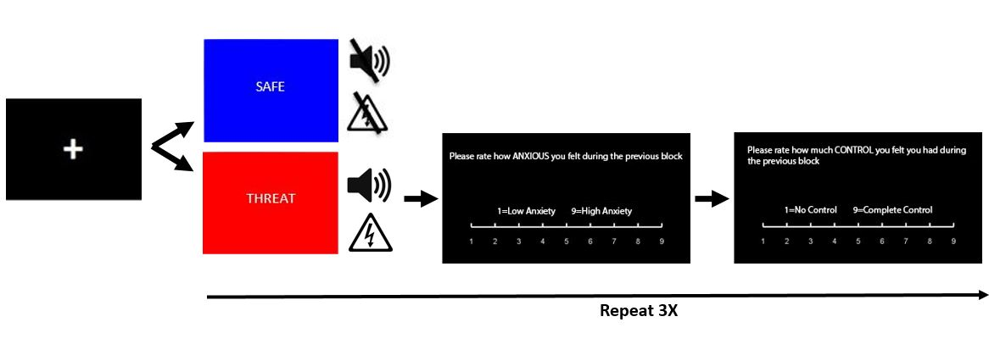

*Trial with prior warning to aversive stimuli:*

